Computer Introduction:

1.What is a computer?
A computer is an electronic device that manipulates information or data, A computer is any machine that can be programmed to carry out a set of algorithms and arithmetic instructions. It has the ability to store, retrieve, and process data. we can use a computer to type documents, send email, play games, and browse the Web. We can also use it to edit or create spreadsheets, presentations, and even videos.

2. What are the different components of a computer? Explain in detail with examples.
The five main components that make up a typical, present-day computer include:
- A motherboard
- A Central Processing Unit (CPU)
- A Graphics Processing Unit (GPU), also known as a video card
- Random Access Memory (RAM), also known as volatile memory
- Storage: Solid State Drive (SSD) or Hard Disk Drive (HDD)

1. The motherboard
What it is: All components of a computer communicate through a circuit board called the motherboard.
What it does: Think of the motherboard as the glue that holds everything else together.

2. The Central Processing Unit (CPU)
What it is: The CPU is often called the "brain" of a computer, thanks to its direct plug connection to the motherboard, and communication with all of the computer’s other components.
What it does: Whenever you write a line of code (in Python, Java, C++, or any other programming language), it's broken down into assembly language—which is a language that the processor can understand. It fetches, decodes, and executes these instructions.
And that’s where the CPU comes in—all the processes a computer handles are taken care of by the CPU.

3. The Graphics Processing Unit (GPU)
What it is: It's not uncommon to hear gamers obsess over the next new graphics card, as these graphic cards make it possible for computers to generate high-end visuals like those found in the many different types of video games.
In addition to video games, though, good graphics cards also come in handy for those who rely on images in order to execute their craft, like 3D modelers using resource-intensive software.
What it does: Graphics cards often communicate directly with the display monitor.

4. Random Access Memory (RAM)
What it is: RAM, also known as volatile memory, stores data regarding frequently accessed programs and processes. (It's called volatile memory because it gets erased every time the computer restarts.)
What it does: RAM helps programs and games start up and close quickly

5. Storage
What it is: All computers need somewhere to store their data. Modern computers either use a Hard Disk Drive (HDD) or Solid State Drive (SSD).
What it does: HDDs are made of an actual disk onto which data is stored. The disk is read by a mechanical arm. (HDDs are cheaper than SSDs, but are slowly becoming more and more obsolete.)
SSDs (think SIM cards) have no moving parts and are faster than a hard drive, because no time is spent waiting for a mechanical arm to find data on a physical location on the disk

3. What is computer operating system? Explain different types of them examples.

An Operating system (OS) is software which acts as an interface between the end user and computer hardware. Every computer must have at least one OS to run other programs. An application likes Chrome, MS Word, Games, etc needs some environment in which it will run and perform its task. The OS helps you to communicate with the computer without knowing how to speak the computer's language. It is not possible for the user to use any computer or mobile device without having an operating system.

Types of Operating system
- Batch Operating System
- Multitasking/Time Sharing OS
- Multiprocessing OS
- Real Time OS
- Distributed OS
- Network OS
- Mobile OS

functions of operating system
The controls and coordinates the use of hardware among the different processes and applications. It provides the various functionalities to the users. The following are the main job of operating system .
- Resource utilization
- Resource allocation
- Process management
- Memory management
- File management
- I/O management
- Device management

Batch Operating System
Some computer processes are very lengthy and time-consuming. To speed the same process, a job with a similar type of needs are batched together and run as a group.
The user of a batch operating system never directly interacts with the computer. In this type of OS, every user prepares his or her job on an offline device like a punch card and submits it to the computer operator.

Multi-Tasking/Time-sharing Operating systems
Time-sharing operating system enables people located at a different terminal (shell) to use a single computer system at the same time. The processor time (CPU) which is shared among multiple users is termed as time sharing.

Real time OS
A real time operating system time interval to process and respond to inputs is very small. Examples: Military Software Systems, Space Software Systems.

Distributed Operating System
Distributed systems use many processors located in different machines to provide very fast computation to its users.

Network Operating System
Network Operating System runs on a server. It provides the capability to serve to manage data, user, groups, security, application, and other networking functions.

Mobile OS
Mobile operating systems are those OS which is especially that are designed to power smart phones, tablets, and wearable’s devices.
Some most famous mobile operating systems are Android and iOS, but others include BlackBerry, Web, and watchOS.

4. Explain computer software and hardware with examples.

Hardware
The term hardware refers to mechanical device that makes up computer. Computer hardware consists of interconnected electronic devices that we can use to control computer’s operation, input and output. Examples of hardware are CPU, keyboard, mouse, hard disk, etc

Hardware Components
Computer hardware is a collection of several components working together. Some parts are essential and others are added advantages. Computer hardware is made up of CPU and peripherals as shown in image below.
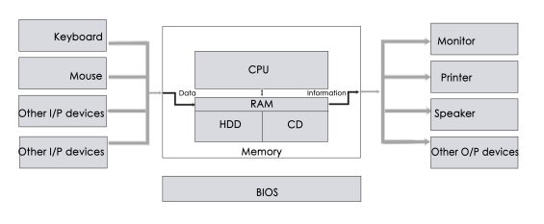

Software
A set of instructions that drives computer to do stipulated tasks is called a program. Software instructions are programmed in a computer language, translated into machine language, and executed by computer. Software can be categorized into two types −
- System software
- Application software

System Software
System software operates directly on hardware devices of computer. It provides a platform to run an application. It provides and supports user functionality. Examples of system software include operating systems such as Windows, Linux, Unix, etc.
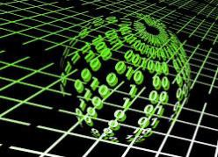

Application Software
An application software is designed for benefit of users to perform one or more tasks. Examples of application software include Microsoft Word, Excel, PowerPoint, Oracle, etc.
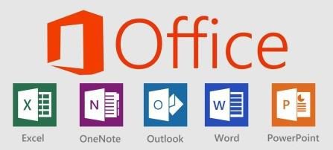

Sr.No. | Software | Hardware
1 | It is a collection of programs to bring computer hardware system into operation. | It includes physical components of computer system.
2 | It includes numbers, alphabets, alphanumeric symbols, identifiers, keywords, etc. | It consists of electronic components like ICs, diodes, registers, crystals, boards, insulators, etc.
3 | Software products evolve by adding new features to existing programs to support hardware. | Hardware design is based on architectural decisions to make it work over a range of environmental conditions and time.
4 | It will vary as per computer and its built-in functions and programming language. | It is mostly constructed for all types of computer systems.
5 | It is designed and developed by experienced programmers in high-level language. | The hardware can understand only low-level language or machine language.
6 | It is represented in any high-level language such as BASIC, COBOL, C, C++, JAVA, etc. | The hardware works only on binary codes 1’s and 0’s.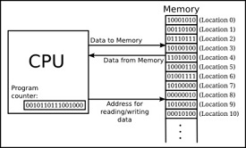
7 | The software is categorized as operating system, utilities, language processor, application software, etc. | The hardware consists of input devices, output devices, memory, etc.

Programming Languages Introduction:

1. What is a programming language?
A programming language is a set of commands, instructions, and other syntax use to create a software program. Languages that programmers use to write code are called "high-level languages." This code can be compiled into a "low-level language," which is recognized directly by the computer hardware.

2. Explain different types of programming languages with examples.
High-level languages are designed to be easy to read and understand. This allows programmers to write source code in a natural fashion, using logical words and symbols. For example, reserved words like function, while, if and else are used in most major programming languages. Symbols like <, >, ==, and != are common operators. Many high-level languages are similar enough that programmers can easily understand source code written in multiple languages.

Examples of high-level languages include C++, Java, Perl, and PHP.

Languages like C++ and Java are called "compiled languages" since the source code must first be compiled in order to run.

Languages like Perl and PHP are called "interpreted languages" since the source code can be run through an interpreter without being compiled. Generally, compiled languages are used to create software applications, while interpreted languages are used for running scripts, such as those used to generate content for dynamic websites.

Low-level languages include assembly and machine languages. An assembly language contains a list of basic instructions and is much more difficult to read than a high-level language. In rare cases, a programmer may decide to code a basic program in an assembly language to ensure it operates as efficiently as possible. An assembler can be used to translate the assembly code into machine code. The machine code, or machine language, contains a series of binary codes that are understood directly by a computer's CPU. Needless to say, machine language is not designed to be human readable.

Low level languages are assembly languages, such as IBM 360 assembler, PDP-10 assembler, Intel x86 assembler, etc

3. What is a compiler and an interpreter. Explain in detail with examples.

Compliers and interpreters are programs that help convert the high level language (Source Code) into machine codes to be understood by the computers.

Complier
-Compiler scans the entire program and translates the whole of it into machine code at once.
-A compiler takes a lot of time to analyze the source code. However, the overall time taken to execute the process is much faster.
-A compiler always generates an intermediary object code. It will need further linking. Hence more memory is needed.
-A compiler generates the error message only after it scans scans the complete program and hence debugging is relatively harder while working with a compiler.
-A Compliers are used by programming languages like C and C++ for example.

Interpreter
-An interpreter takes very less time to analyze the source code
Interpreter translates just one statement of the program at a time into machine code.
-An interpreter takes very less time to analyze the source code. However, the overall time to execute the process is much slower.
- An interpreter does not generate an intermediary code. Hence , an interpreter is highly efficient in terms of its memory.
- Keeps translating the program continuously till the first error is confronted. If any error is spotted, it stops working and hence debugging becomes easy.
- Interpreters are used by programming languages like Ruby and Python for example.

Software Engineering Introduction:
1. What is software engineering? What are the different phases involved in software engineering?
. The main objective of software engineering is to develop methods for large systems, which help developers obtaining high-quality software in minimum time and at low cost. Therefore, it is essential to perform software development in phases. This phased development of software is often referred to as the software development life cycle (SDLC) or software life cycle
Requirement gathering and analysis.
Design.
Coding and Implementation.
Testing.
Deployment.
Maintenance.

2. What is a software development life cycle? Explain different types of software development life cycles with examples?
SDLC or the Software Development Life Cycle is a process that produces software with the highest quality and lowest cost in the shortest time possible. SDLC provides a well-structured flow of phases that help an organization to quickly produce high-quality software which is well-tested and ready for production use. methodology focuses on the following phases of software development:
- Requirement analysis
- Planning
- Software design such as architectural design
- Software development
- Testing
- Deployment

1. Identify the Current Problems
“What are the current problems?” This stage of the SDLC means getting input from all stakeholders, including customers, salespeople, industry experts, and programmers. Learn the strengths and weaknesses of the current system with improvement as the goal.

2. Plan
“What do we want?” In this stage of the SDLC, the team determines the cost and resources required for implementing the analyzed requirements. It also details the risks involved and provides sub-plans for softening those risks.
In other words, the team should determine the feasibility of the project and how they can implement the project successfully with the lowest risk in mind.

3. Design
“How will we get what we want?” This phase of the SDLC starts by turning the software specifications into a design plan called the Design Specification. All stakeholders then review this plan and offer feedback and suggestions. It’s crucial to have a plan for collecting and incorporating stakeholder input into this document. Failure at this stage will almost certainly result in cost overruns at best and the total collapse of the project at worst.

4. Build
“Let’s create what we want.”
At this stage, the actual development starts. It’s important that every developer sticks to the agreed blueprint. Also, make sure you have proper guidelines in place about the code style and practices.
For example, define a nomenclature for files or define a variable naming style such as camelCase. This will help your team to produce organized and consistent code that is easier to understand but also to test during the next phase.

5. Code Test
“Did we get what we want?” In this stage, we test for defects and deficiencies. We fix those issues until the product meets the original specifications.
In short, we want to verify if the code meets the defined requirements.

6. Software Deployment
“Let’s start using what we got.”
At this stage, the goal is to deploy the software to the production environment so users can start using the product. However, many organizations choose to move the product through different deployment environments such as a testing or staging environment.
This allows any stakeholders to safely play with the product before releasing it to the market. Besides, this allows any final mistakes to be caught before releasing the product.

3. Compare different types of software development life cycles.
The Software Development Life Cycle (SDLC) in software engineering is a methodology that defines the logical steps for developing a custom software product.
This methodology is used to structure, plan and control the software development process. In simple terms, we can define SDLC as a methodology that a developer can use to standardize the process of software development.
A number of SDLC models are available, choosing the right one is no easy task. In this article we'll try to highlight the main advantages and disadvantages of some commonly used SDLCs.

Waterfall Model
This is one of the simplest, classic life-cycle models, also known as the 'linear-sequential' life cycle model. In a waterfall model, each phase must be completed before moving onto the next. A review process is scheduled at the end of each phase to check that the project is on the right track. The steps are as follows:
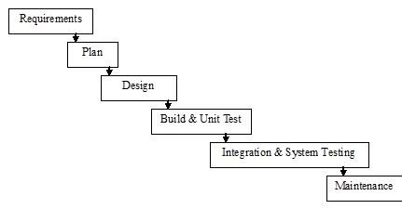
Advantages of the waterfall model
-Simple to understand and use.
-Each phase is independent of other phases and is processed and completed separately.
-Suitable for smaller projects, and for projects where the requirements are clearly outlined.

Disadvantages of the waterfall model
-No output or working software is produced until late in the life cycle.
-High degree of uncertainty and risks.
-Not a good choice for big or ongoing projects.

Iterative Model
The Iterative model can be thought of as a “multi-waterfall” cycle. Cycles are divided into smaller and easily managed iterations. Each iteration passes through a series of phases, so after each cycle you will get working software.
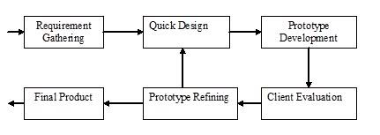
Advantages of the iterative model
-Produces working software early during the lifecycle.
-More flexible as scope and requirement changes can be implemented at low cost.
-Testing and debugging is easier, as the iterations are small.
-Low risks factors as the risks can be identified and resolved during each iteration.

Disadvantages of the iterative model
-This model has phases that are very rigid and do not overlap.
-Not all the requirements are gathered before starting the development; this could lead to problems related to system architecture at later iterations.

Spiral Model
The spiral model is similar to the iterative model, but places more emphasis on risk analysis. The steps involved in this model can be generalised as follows:
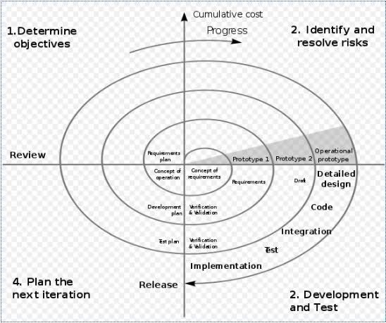
System requirements are defined in as much detail as possible by involving various users, so as identify the various aspects of the system.
A preliminary design of the system is created. This is the most crucial step in the spiral model, as it helps in developing cost-effective strategies for working on a project.
Using the preliminary design, a prototype for the new system is developed. This is generally a scaled down system, which represents an approximate characteristics of the final output.
Consecutive prototypes are then evolved through a fourfold procedure
- Strengths, weaknesses and risks of the previous prototype are evaluated
- Requirements for the new prototype are defined
- Planning and design of the new prototype begins
- Developing and testing the new prototype are carried out
Advantages of the spiral model
-Good for large and critical projects
-Working software is produced early during the lifecycle.
-Large amount of risk analysis.

Disadvantages of the spiral model
-Involves higher cost.
-Not suitable for smaller projects.
-Project success depends on the risk analysis phase - hence, it requires highly specific expertise in risk analysis.

Prototype Model
The prototype model is used to overcome the limitations of waterfall model. In this model, instead of freezing the requirements before coding or design, a prototype is built to clearly understand the requirements. This prototype is built based on the current requirements. Through examining this prototype, the client gets a better understanding of the features of the final product. The processes involved in the prototyping approach are shown in the figure below.

Advantages of the prototype model
-Benefits from user input.
-As a working model of the system is provided, users get a better understanding of the system that is being developed.
-Errors and risks can be detected at a much earlier stage, as the system is developed using prototypes.
Disadvantages of the prototype
-Increases complexity of the overall system.
-Involves exploratory methodology and therefore involves higher risk.
-Involves implementing and then repairing the way a system is built, so errors are an inherent part of the development process.

- What is PYTHON programming language? Give a summary about its origin and applications.

Python is an open source programming language made to both look good and be easy to read. A programmer named Guido van Rossum made it in 1991. Python is named after the television show Monty Python's Flying Circus. Many examples and tutorials include jokes from the show.
Python is an interpreted language. Interpreted languages do not need to be compiled to run. A program called an interpreter will run python code on any kind of computer it can run on itself. This means if the programmer needs to change the code they can quickly see the results. This also means Python is slower than a compiled language like C, because it is not running machine code directly.
Python is a good programming language for beginners. It is a high-level language, which means a programmer can focus on what to do instead of how to do it. Writing programs in Python takes less time than in another language.
Python drew inspiration from other programming languages like C, C++, Java, Perl, and Lisp

Currently, PSF supports two versions, Python 2.x & Python 3.x. Python 2.0 was released in October 2000 and includes a large number of features. PSF continues to support version Python 2 because a large body of existing code could not be forward ported to Python 3. So, they will support Python 2 until 2020.
Python 3.0 was released on December 3rd, 2008. It was designed to rectify certain flaws in earlier version. This version is not completely backward-compatible with previous versions. However, many of its major features have since been back-ported to the Python 2.6.x and 2.7.x version series. Releases of Python 3 include 2 to 3 utilities to facilitate the automation of translation of Python 2 code to Python 3.
The following table lists all the important versions history of Python:
Version | Release Date | Important Features
Python 0.9.0 | February 1991 | - Classes with inheritance exception handling  - Functions  - Modules
Python 1.0 | January 1994 | - Functional programming tools (lambda, map, filter and reduce).  - Support for complex numbers.  - Functions with keyword arguments
Python 2.0 | October 2000 | - List comprehension.  - Cycle-detecting garbage collector.  - Support for Unicode. Unification of data types and classes
Python 2.7.0 - Current version | July 2010
Python 2.7.15 - Current sub-version | May 2018
Python 3 | December 2008 | - Backward incompatible.  - print keyword changed to print() function  - raw_input() function depreciated  - Unified str/Unicode types.  - Utilities for automatic conversion of Pytthon 2.x code
Python 3.6 | December 2016
Python 3.6.5 | March 2018
Python 3.7.0 - Current Version | May 2018 | - New C API for thread-local storage  - Built-in breakpoint()  - Data classes  - Context variables

Python Features:
- Python is an interpreter-based language, which allows execution of one instruction at a time.
- Extensive basic data types are supported e.g. numbers (floating point, complex, and unlimited-length long integers), strings (both ASCII and Unicode), lists, and dictionaries.
- Variables can be strongly typed as well as dynamic typed.
- Supports object-oriented programming concepts such as class, inheritance, objects, module, namespace etc.
- Cleaner exception handling support.
- Supports automatic memory management.

Python Advantages
- Python provides enhanced readability. For that purpose, uniform indents are used to delimit blocks of statements instead of curly brackets, like in many languages such as C, C++ and Java.
- Python is free and distributed as open-source software. A large programming community is actively involved in the development and support of Python libraries for various applications such as web frameworks, mathematical computing and data science.
- Python is a cross-platform language. It works equally on different OS platforms like Windows, Linux, Mac OSX etc. Hence Python applications can be easily ported across OS platforms.
- Python supports multiple programming paradigms including imperative, procedural, object-oriented and functional programming styles.
- Python is an extensible language. Additional functionality (other than what is provided in the core language) can be made available through modules and packages written in other languages (C, C++, Java etc)
- A standard DB-API for database connectivity has been defined in Python. It can be enabled using any data source (Oracle, MySQL, SQLite etc.) as a backend to the Python program for storage, retrieval and processing of data.
- Standard distribution of Python contains the Tkinter GUI toolkit, which is the implementation of popular GUI library called Tcl/Tk. An attractive GUI can be constructed using Tkinter. Many other GUI libraries like Qt, GTK, WxWidgets etc. are also ported to Python.
- Python can be integrated with other popular programming technologies like C, C++, Java, ActiveX and CORBA.

Python Application Types
Even though Python started as a general-purpose programming language with no particular application as its focus, over last few years it has emerged as the language of choice for developers in some application areas. Some important applications of Python are summarized below:

Data Science
Python experienced a recent emergence in popularity charts mainly because of its Data science libraries. Huge amount of data is being generated today by web applications, mobile applications and other devices. Companies need business insights from this data.
Today Python has become the language of choice for data scientists. Python libraries like NumPy, Pandas and Matplotlib are extensively used in the process of data analysis, including the collection, processing and cleansing of data sets, applying mathematical algorithms and generating visualizations for the benefit of users. Commercial and community Python distributions by third-parties such as Anaconda and ActiveState provide all the essential libraries required for data science.

Machine Learning
This is another key application area of Python. Python libraries such as Scikit-learn, Tensorflow and NLTK are widely used for the prediction of trends like customer satisfaction, projected values of stocks etc. Some of the real-world applications of machine learning include medical diagnosis, statistical arbitrage, basket analysis, sales prediction etc.

Web Development
This is another application area in which Python is becoming popular. Web application framework libraries like django, Pyramid, Flask etc. make it very easy to develop and deploy simple as well as complex web applications. These frameworks are used extensively by various IT companies. Dropbox for example uses django as a backend to store and, synchronize local folders.
Most of the web servers today are compatible with WSGI (Web Server Gateway Interface) - a specification for the universal interface between Python web frameworks and web servers. All leading web servers such as Apache, IIS, Nginxetc can now host Python web applications. Google's App Engine hosts web applications built with almost all Python web frameworks.

Image Processing
The OpenCV library is commonly used for face detection and gesture recognition. OpenCV is a C++ library, but has been ported to Python. Because of the rapid development of this feature, Python is a very popular choice from image processing.

Game Development
Python is a popular choice for game developers. The PyGame library is extensively used for building games for desktop as well as for mobile platforms. PyGame applications can be installed on Android too.

Embedded Systems and IoT
Another important area of Python application is in embedded systems. Raspberry Pi is a very popular yet a low-cost single-board computer. It is being extensively used in automation products, robotics, IoT, and kiosk applications. Popular microcontrollers like Arduino are used in many IoT products and are being programmed with Python. A lightweight version of Python called Micropython has been developed especially for microcontrollers. A special Micropython-compatible controller called PyBoard has also been developed.

Android Apps
Although Android apps are predominantly developed using Android SDK, which is similar to Java, Python can also be used to develop Android apps. Python's Kivy library has all the functionalities required for a mobile application.

Automated Jobs
Python is extremely useful and widely used for automating CRON (Command Run ON) jobs. Certain tasks like backups, defined in Python scripts can be scheduled to be invoked automatically by the operating system scheduler to be executed at predefined times.
Python is embedded as a scripting language in many popular software products. This is similar to VBA used for writing macros in Excel, PowerPoint, etc. Python API is integrated with Maya, PaintShop Pro, etc.

